Project Plan

*<Name of Project>*

Table of Contents

Project Plan Definition 1

Purpose 1

1. Introduction 2

Purpose of the Plan 2

Background Information about the Project 2

Project Approach 2

2. Goals and Objectives 3

Business Goals and Objectives 3

Project Goals and Objectives 3

3. Scope 4

Scope Definition 4

Costs, Benefits and Risks 4

Project Products/Deliverables List 5

Milestones 5

Impacted Business Areas 5

4. Assumptions 7

5. Constraints 7

Project Constraints 7

Related Projects 7

Critical Dependencies 7

6. Quality Management Approach 8

Activity Reviews/Walkthroughs 8

Tools and Techniques 8

Test Approach 8

Performance/Quality Standards 8

Quality Management Roles 8

Training 8

7. Project Management Approach 9

Work Breakdown Structure (WBS) Gantt Chart 9

Basis of Estimates 9

Project Effort Estimation 9

Project Standards 9

Project Roles and Responsibilities 9

Change and Issue Management Approach 10

Communications and Control Approach 10

8. Attachments/Appendices 11

Project Work Plan 11

Project Network-PERT Chart 11

Project Team Contact Directory 11

Risk Assessment 11

Project Budget Report/Cost Benefit Analysis Report 11

Project Impact Report 11

9. Approvals 12

Sign-off Sheet 12

Table of ContentsIntroduction 2

Introduction 5

Purpose of Plan 5

Background Information about the Project 5

Project Approach 5

Goals and Objectives 6

Business Goals and Objectives 6

Project Goals and Objectives 6

Scope Definition 7

Costs, Benefits and Risks 7

Project Products/Deliverables List 8

Milestones 9

Impacted Business Areas 9

Assumptions 10

Project Assumptions 10

Constraints 11

Project Constraints 11

Related Projects 11

Critical Dependencies 11

Quality Management Approach 12

Activity Reviews/Walkthroughs 12

Tools and Techniques 12

Test Approach 12

Performance/Quality Standards 12

Quality Management Roles 12

Training 12

Project Management Approach 13

Work Breakdown Structure (WBS) Gantt Chart 13

Basis of Estimates 13

Project Effort Estimation 13

Project Standards 13

Project Roles and Responsibilities 13

Communications and Control Approach 14

Attachments/Appendices 15

Appendix A - Project Work Plan 15

Appendix B - Project Network-PERT Chart 15

Appendix C - Project Team Contact Directory 15

Appendix D - Risk Assessment 15

Appendix E - Project Budget Report/Cost Benefit Analysis Report 15

Appendix F - Project Impact Report 15

Appendix G - Project Resource Requirements Checklist 16

Approvals 18

Sign-off Sheet 18

Introduction

Purpose of Plan

The company we work with produces tractor parts. MAPSAN company has been in this sector for many years. The biggest reason we choose this company is that it is closed around 6 months. When we first went to the factory we found that there were too many problems and started to work on serious problem. Our priority was in plant design.

Background Information about the Project

The company was built in 1954 in Kazan/ANKARA. Since then, they provide products to the agriculture industry such as drawbar, top link upper lift arms, fixed side link, lower lift arms and drawbolt with elevator. These parts using in the tractor. On the other hand, these parts make farmers’ jobs easier and more effective. The company has been manufacturing for more than 50 years. The company works with special projects for individuals and companies rather than mass production. Production usually made to order. The company provides special solutions and designs to the firms.

The company that we work is in tractor parts and tractor spare parts sector. According to TARMAKBİR Turkish Agricultural Machinery and Equipment Manufacturers Association Sector Report on 06 November 2019, Turkey Agricultural Machinery Industry, Turkey is growing in parallel with the economy, is also developing the product range and the quality of next-generation standards. Due to this development, the number of firms in the sector increases and the brand value of the sector increases. There are some problems in the sector. The most popular problem is insufficiency on the number of machinery and equipment is 62%. This will be damage to agriculture and the economy. Making damages and losses to minimize and improve productivity. So companies should produce more and effective parts.

The point is identifies bottlenecks and improves productivity in the production line. We have observed the company machines and plant design. The most important points are time, money and design.

Project Approach

To determine how to improve the layout of the production area and improve production time of one of the products which main and most producing product of the factory. First, we measure times after that, we will examine scenarios and we observe the differences and collect data and compare them. Exploration of the range of possible futures and triggers is needed to analyze facility needs using analytical techniques. Such as systematic layout planning (SLP) and scenario planning to step forward in production analysis. We will search and analysis for our project throughout creative work, literature resources, and fieldwork. We have collected some data that we measure the time throughout raw material to the final product. We will use analytical techniques, such as SWOT analysis, SCAN, SLP, and scenario planning to explore the range of possible futures and the triggers used to analyze the facility's needs.

**Strengths, Weaknesses, Opportunities and Threats Analysis (SWOT):** Environmental analysis is a critical part of the strategic management planning process. The SWOT (Strengths, Weaknesses, Opportunities, Threats) framework is proposed by many as an analytical tool which should be used to categorize significant environmental factors both internal and external to the organization.

**Systematic Layout Planning (SLP):** The systematic layout planning (SLP) is a procedure used to set the layout of workplace in a plant notice to the logical relationship between workplace with high frequency are placed close to each other. SLP technique applied to optimize the existing layout. The application is expected to make the fastest material flow with the lowest cost and least amount of material handling.

**Scenerio Planning**: Scenarios are tools for thinking ahead to anticipate the changes that will impact the organization. Scenarios can be considered instructive simulations of possible operating conditions. For each potential change, discuss three different future organizational scenarios (including the best case, worst case, and reasonable case), which may arise within the organization as a result of each change.

**Strategic Creative Analysis (SCAN):** Strategic Creative Analysis is a process for strategic planning, decision making and analyzing case studies. An example of a strategic planning technique that incorporates a SWOT analysis is SCAN analysis.

Goals and Objectives

Goal

The goal is identifies bottlenecks and improves productivity in the production line. We have observed the company machines and plant design. The most important points are time, money and design.

Project Objectives

           Our project identifies bottlenecks and improves productivity in the production line. We have observed the company machines and plant design. They use some machines in the factory for manufacturing. These are CNC machines, turning machines, and drills. We have observed some machines are very old. So these machines are making some problems and delays in manufacturing. On the other hand, machines did not installed in a specific order. For example, part A will go to the drill machine after leaving the CNC machine. But it’s motion takes too long. Because of the distance is too far between the machines. These situations can cause some losses. So, there is not a good planning plant design.

Conclusion, the reason behind the idea of starting a project is to identify the bottlenecks and improve productivity in the production line.

Scope

Scope Definition

Eight functional objectives have been identified for project completion:

1. To provide a suitable working environment for the workers by placing the machines properly.
2. Measuring the production times of the parts produced on the machines,
3. The productivity can be realized by using production acceleration techniques to increase productivity remarkably,
4. Determination of visible losses by making fishbone diagram,
5. Determination of the right products to calculate and improve the costs by performing ABC Analysis,
6. Performing Pareto Analysis using the production times on the machines and detecting the bottlenecks,
7. Determination of losses by measuring the transport time of the products in the plant between the machines and, if necessary, carrying out improvement studies related to plant design,
8. Risk driven project management implemented.

Costs, Benefits and Risks

Describe each risk type in the table. For each, determine the cost of the event and the likelihood that the event might occur. Identify how you will reduce the impact of each risk event (mitigation).*

|  |  |  |  |
| --- | --- | --- | --- |
| Risk Event | Cost of Event | Likelihood of Event | Mitigation Strategy |
|  |  |  |  |
|  |  |  |  |
|  |  |  |  |
|  |  |  |  |
|  |  |  |  |

*Note: If the Risk Analysis Detail becomes too large and cumbersome, move it to an Appendix with a reference at this location.

Project Products/Deliverables List

This worksheet is designed to keep track of all of your project’s deliverables in an orderly fashion. Name and describe each deliverable and cite the version, phase of the project lifecycle in which it must be delivered, delivery schedule and status. Include the Team Member who is the point person for either creating the deliverable or making sure it gets completed.

NOTE: You may wish to attach separate sheets that checklist the specific Acceptance Criteria that must be met by a given deliverable.

| Stage | Deliverable Name | Description | Acceptance Criteria | Assigned to (Team Member Name) | In Progress  (Date) | Delivered  (Date) | Accepted  (Date) |
| --- | --- | --- | --- | --- | --- | --- | --- |
| Initiation | Capstone Project | Breakthrough of Product | Supervisor | Oğuzhan Mazlumoğlu  Ömer Ayberk Lodi  Ömer Künyeli | 20 October 2019 | 17 January 2020 | 04 April 2020 |
| Planning | Analyze of Product | Reduce Product Manufacturing Errors | Supervisor | Oğuzhan Mazlumoğlu  Ömer Ayberk Lodi  Ömer Künyeli | 24 October 2019 | 17 January 2020 | 04 April 2020 |
| Requirements Analysis | Time and Motion Study | Time Measurement During Installation | Factory Manager and Supervisor | Oğuzhan Mazlumoğlu  Ömer Ayberk Lodi  Ömer Künyeli | 10 November 2019 | 17 January 2020 | 04 April 2020 |
| Business Analysis | Gantt Chart | Join our Planning Over Time | Supervisor | Oğuzhan Mazlumoğlu  Ömer Ayberk Lodi  Ömer Künyeli | 24 December | 17 January 2020 | 04 April 2020 |
| Design | Plant Design | Edit Machine Layout on Site | Factory Manager | Oğuzhan Mazlumoğlu  Ömer Ayberk Lodi  Ömer Künyeli | 01 December 2019 – 06 January 2020 | 17 January 2020 | 04 April 2020 |
| Implementation | Process Improvement and Plant Design in Production Facilities | Finding Bottlenecks and Reducing Losses | Supervisor | Oğuzhan Mazlumoğlu  Ömer Ayberk Lodi  Ömer Künyeli | 01 December 2020 | 17 January 2020 | 04 April 2020 |
| Close | Reduce Process Losses | Minimize Factors of Cost and Errors improve product quality | Supervisor | Oğuzhan Mazlumoğlu  Ömer Ayberk Lodi  Ömer Künyeli | 04 April 2020 | 04 April 2020 | 04 April 2020 |

Milestones

* + Determine Problems

From the day we reached an agreement with the company to determine what the problem was, we began to think about the problems. It was a turning point with the literature research we conducted. The data we obtained during our time analysis was another milestone and made it easier for us to start literature research.

* + Determines Areas for Project

We did literature research with time analyzes and information we obtained from the factory. As a result of this research, we examined similar projects. The resources we found were useful for us. We learned about plant design.

* + Obtain Data Knowledge about Industry

Examining the assembly process and operations of products on CNC machines. While making our own observations, we had the opportunity to talk to the masters. We continued our research with the information they provided, and the notes we received during our investigations became important. In this process, we saw who worked in which department, how they carried out on-site transport and how they solved a problem.

* + Meeting with Company advisors

When we met the company manager, we got information about the company. We learned that the company was closed for a long time and that it was an order-based company. When we examined the plant design we received from the company, we found that they had used the same design for a long time and this was insufficient. The company does not stock because the ordering procedure works. We researched the information we obtained from this section, which is especially related to the plant design. The literature was part of our research.

* + Develop Project Plan

First, we made a draft in the development phase of the project. We tried to move over this outline. This draft gives us information about which work we will do and / or when the project will be completed (WBS - GANTT Chart).

After completing this drafting phase, we made observations, observations, talk with the workers and conducted research to define the task. After these reviews, our table became more clear. We saw that we were missing and made corrections. We received data from the company and added them to the revisions. After each of our researches, we held meetings within ourselves and interviews with our advisor. We saw where our missing ones are.

Impacted Business Areas

During our project, we were most affected by the sections and / or the periods we lived or could not train in the areas of work to be completed. We lost a lot of time during the literature research. We had trouble finding similar projects. Other than that, we were interested in the analysis of a part and there were delays in trying to find the part's losses during production. We've held it for several times and tried to identify the bottlenecks. We made continuous changes in project planning. We showed this with the GANTT chart. During this project, we took advantage of the Project Management course. We used the course notes to make our corrections. While examining the duration analysis, we took advantage of the resources of the work and time study course that I took before. We have corrected our shortcomings over time in termining the necessary resources or the work we need to do. Our work break structure helped us here. During the literature research, we saw the most of what we lack here. After correcting WBS, we did better research. In this way, we changed the GANTT chart again towards the end of the period.

Assumptions

Project Assumptions

Constraints

Project Constraints

Related Projects

Critical Dependencies

Quality Management Approach

Activity Reviews/Walkthroughs

Tools and Techniques

Test Approach

Performance/Quality Standards

Quality Management Roles

Training

Project Management Approach

Work Breakdown Structure (WBS)

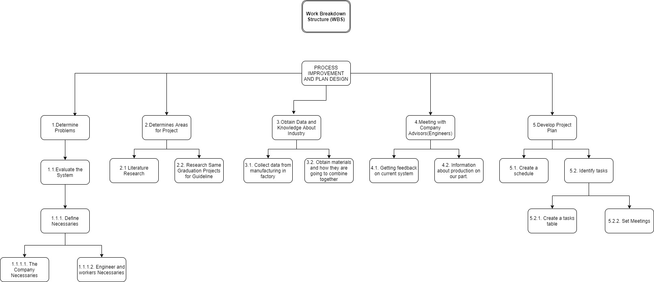

Basis of Estimates

Since we show the breakdown from WBS work packages to the final product, we divided our main title into 5 parts. We have determined where each piece needs it. In line with these processes, we created our WBS scheme.

Project Effort Estimation

Project Standards

Project Roles and Responsibilities

Detailed Roles and Responsibilities Definitions Chart*

|  |  |
| --- | --- |
| **Critical Project Elements** | **Team member(s) and associated skills/interests** |
| Knowledge about industry and materials | Ömer Ayberk Lodi (Research) |
| Data | Oğuzhan Mazlumoğlu(Data Gathering) |
| Research about same projects in industry | Ömer Künyeli (Research) |

*Note: If the Detailed Roles and Responsibilities Definitions Chart becomes too large and cumbersome, move it to an Appendix with a reference at this location.

Communications and Control Approach

Project team members have their own roles and responsibilities. Some of the team members are more advantageous in a few subjects because they take more boat elective courses. When we went to work within the project or to the company, we were divided into three. We had PARETO analysis with the data obtained from this group. We think this data makes our job easier. The other group member carried out researches on plant design within the factory. In line with the information we have obtained and the data we have obtained, we have compared the current plant design and made some approaches. We have produced the product production tree scheme (TREE DIAGRAM). We've set a time in the literature study. Everybody did their research and we tried to find the best method. We extracted the WBS and Gantt chart diagrams during this literature research process. One of our most recent schemes is the ABC analysis. We took ideas from each other while making these analyzes and graphs.

Attachments/Appendices

Appendix A - Project Gantt Chart

ekran görüntüsü, bilgisayar içeren bir resim

Açıklama otomatik olarak oluşturuldu

ekran görüntüsü içeren bir resim

Açıklama otomatik olarak oluşturuldu

Appendix B - Project Network-PERT Chart

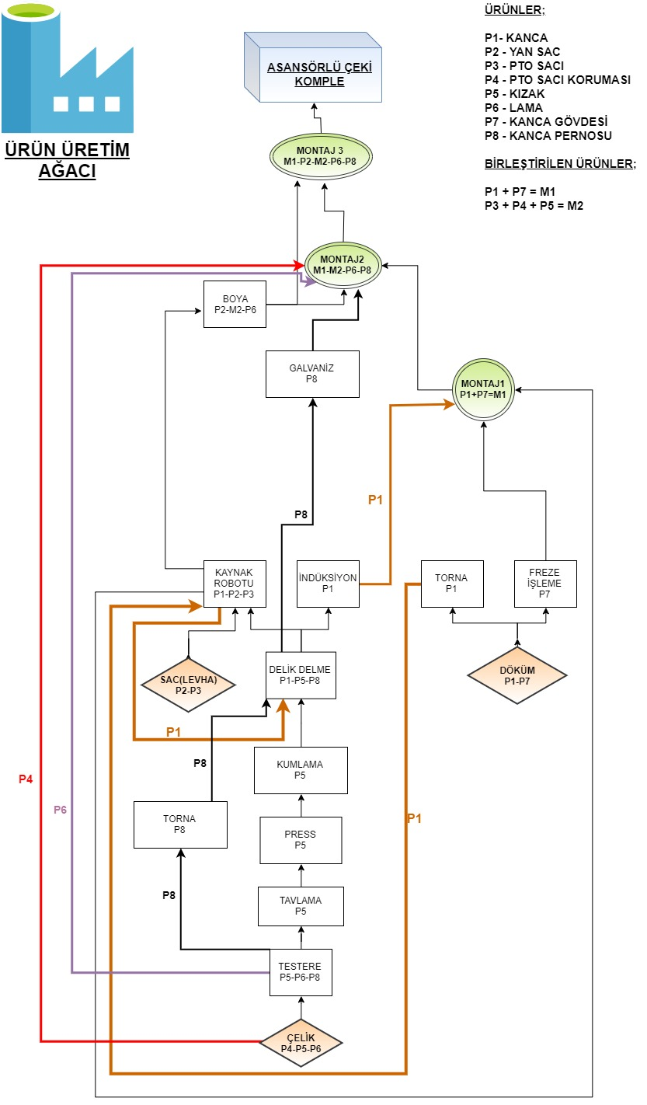

Appendix C - Project Team Contact Directory

Oğuzhan Mazlumoğlu – Ömer Ayberk Lodi – Ömer Künyeli

Appendix D - Risk Assessment



Appendix G - Project Resource Requirements Checklist

| Project Requirements Checklist | | | | | |
| --- | --- | --- | --- | --- | --- |
| Item | Quantity | When  Required? | Availability  Secured? | For How Long? | Comments/  Action |
| Human Resources |  |  |  |  |  |
| Core Team Members |  |  |  |  |  |
| Part-time Team Members |  |  |  |  |  |
| Technical Specialists |  |  |  |  |  |
| Business Experts |  |  |  |  |  |
| Current Systems Experts |  |  |  |  |  |
| Business Sponsors |  |  |  |  |  |
| Consultants |  |  |  |  |  |
| Training Resources |  |  |  |  |  |
| Support staff |  |  |  |  |  |
| Physical Resources |  |  |  |  |  |
| Project Workspace & Supplies: |  |  |  |  |  |
| * Office Space |  |  |  |  |  |
| * Meeting Rooms |  |  |  |  |  |
| * Office Furniture |  |  |  |  |  |
| * Office Supplies |  |  |  |  |  |
| Software: |  |  |  |  |  |
| * Word Processor |  |  |  |  |  |
| * Project Management Tool |  |  |  |  |  |
| * Spreadsheet Tool |  |  |  |  |  |
| * Graphics Tool |  |  |  |  |  |
| * Presentation Tool |  |  |  |  |  |
| * Methodology |  |  |  |  |  |
| * Application Development Tools |  |  |  |  |  |
| * Project Repository |  |  |  |  |  |
| Hardware: |  |  |  |  |  |
| * PCs (configured) |  |  |  |  |  |
| * Network |  |  |  |  |  |
| * Servers |  |  |  |  |  |
| Telecommunication  Facilities: |  |  |  |  |  |
| * Internet Access |  |  |  |  |  |
| * Tele-/Video- Conferencing |  |  |  |  |  |
| * Phones |  |  |  |  |  |
|  |  |  |  |  |  |

Approvals

Sign-off Sheet

I have read the above Project Plan and will abide by its terms and conditions and pledge my full commitment and support for the project.

Executive Sponsor: Date:

Project Manager: Date:

Project Team Member: Date:

Project Team Member: Date:

Project Team Member: Date:

Project Team Member: Date:

Enterprise Manager: Date:

Enterprise Manager: Date:

Enterprise Manager: Date: